Early Career and Student Poster Session on Extreme Heat Resilience

Poster submissions are encouraged from students and early career scientists/professionals as part of a virtual workshop entitled, Advancing the Theory and Practice of Urban Heat Resilience. Posters will be shared through a virtual poster hall at 7:00pm ET on October 19, 2020. Poster presenters will have the opportunity to host a virtual table featuring their poster, share findings, and answer questions via video chat with colleagues and a public audience.
SUBMISSION DEADLINES
To submit your poster, please e-mail the following Submission Requirement information to martinb@agci.org by October 13, 2020. You will receive notification if your poster has been accepted by October 15, 2020. Final posters must be submitted by October 17, 2020 in .pdf, .jpeg, or .png format.
SUBMISSION REQUIREMENTS (due October 13, 2020)
- Corresponding Author E-mail
- Title
- Authors and Author Institutions/Affiliations
- Abstract (Word Limit: 300 words)
POSTER REQUIREMENTS (due October 17, 2020 in .pdf, .jpeg, or .png format)
- ​Title
- Authors and Author Institutions/Affiliations
- Abstract (Word Limit: 300 words)
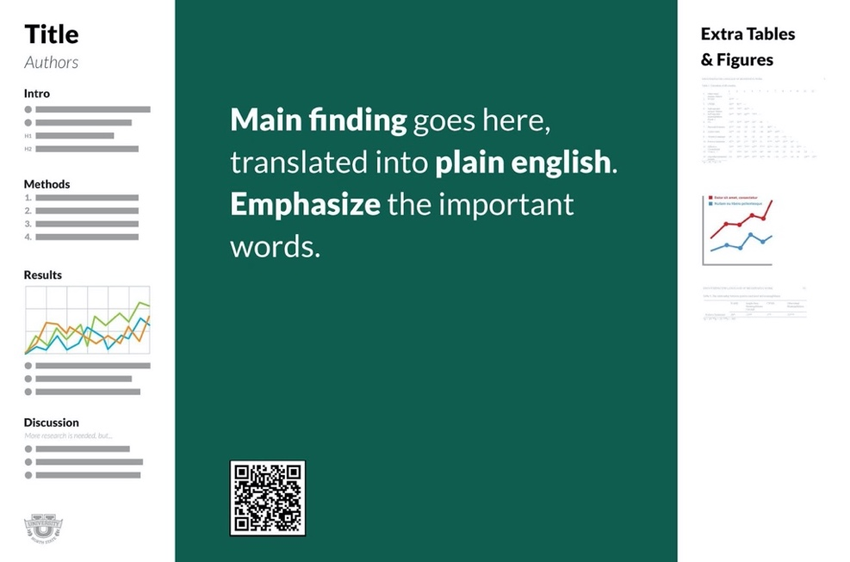
- Purpose/Intro
- Methods
- Results
- Discussion
Please note that posters will be viewed on screen, and font sizes should be sized accordingly. Participants are encouraged to use the Better Poster format, templates available here.

